Cystart Manual: H-1B Application

What is Cystart?

Cystart is a web browser-based interface that allows users to electronically submit immigration services requests to the International Students & Scholars Office. Cystart eliminates the need for paper forms and ensures only accurate, relevant information is added to the Cystart database.
Cystart allows ISD Human Resource Services Delivery Teams and/or departments to submit applications for H-1B employees and perform functions regarding H-1B employees, and it provides H-1B employees the ability to access and update their information as needed.
Using Cystart is straightforward and uses the Iowa State University email system to submit e-forms for review by ISSO staff.
Throughout this manual and within Cystart, the terms department and departmental may refer to either ISD Human Resource Services Delivery Teams and/or departments, depending on the context. You may also see screen shots which use iStart, the generic term used in this software, instead of Cystart.

Adding a Future Scholar in Cystart
Once you receive departmental access to Cystart you are ready to request an H-1B petition in Cystart. If the prospective employee has never been to ISU before, add him/her into the Cystart database.

- Request a copy of the demographic page (photo, personal information) of the applicant’s passport.

- Expand the Departmental Services menu if it is not already expanded.

- Select “Add New Person” (See Figure 1).

- Complete the information.
  - See Appendix C for information on how to correctly format names and contact ISSO if you cannot determine how the name should be formatted

[Tip] Some countries have muliple parts to the last/surname/family name; all should be included
[Tip] All given names (what we think of as first and middle) are included in the given name field
[Tip] In most passports, the date of birth will be entered in the dd/mm/yyyy order

  - The email address does not have to be an official university address.
  - The “institutional university ID” refers to an ISU ID number. If the individual has been issued one, you will be asked to enter that number. If you select “no”, Cystart will assign a temporary ID number starting with “TEMP” to the record.
  - The “network ID” refers to the ISU Net-ID.

Figure 1: Adding a New Person
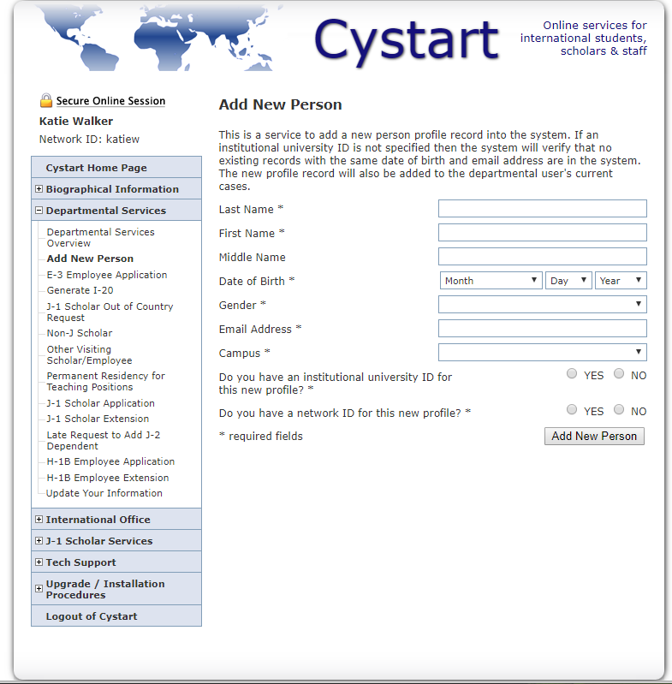

Preparing an H-1B Application in Cystart
Completing the Request: General Notes
- You must complete all fields marked with an asterisk (*) in order to submit an e-form.
- If you receive an error message, you will need to review each field again as Cystart has a technical issue that causes data and uploads to be lost when there is an error in completing the e-form.
  - Note: ISSO’s SUNAPSIS Coordinator is aware of this technical issue but has been unable to resolve it. (8/12/2020)
- If you are in an e-form and want to leave it, click on the MAIN PAGE | TEMP000000 | SCHOLAR NAME link (See Figure 2)
- You have the option to save a draft of most e-forms. However, remember that ISSO cannot take action on a request if any of the e-forms are still in draft status.
- Once completed and finalized, the person completing the e-form must click the Submit button.
- Once an e-form is completed, please ask ISSO to reset it to draft status if further editing is needed instead of canceled the e-form and starting over.
- When uploading documents to Cystart:
  - Use .jpeg or .pdf files only

All foreign language documents must include an English translation
  - Each field accepts only one upload
- All data entered in e-forms will automatically be deleted if the request is pending over 90 days

Completing the Request: Key to the Icons
- Form 7 is forwarded to a second person for approval and will have the arrow in the box once the initial person has completed the form. Once the second person completes and submits the form, the arrow will change to a check mark.
- Forms 1, 3, 4, 5 and 6 will have a check mark in the box when completed.
- Forms 2 and 7 will be half-shaded as they are pending review and approval by ISSO.
- If a box has the pencil icon in it, this form is in draft status and has not yet been completed and submitted in Cystart.

Figure 2: Navigating between e-forms in group

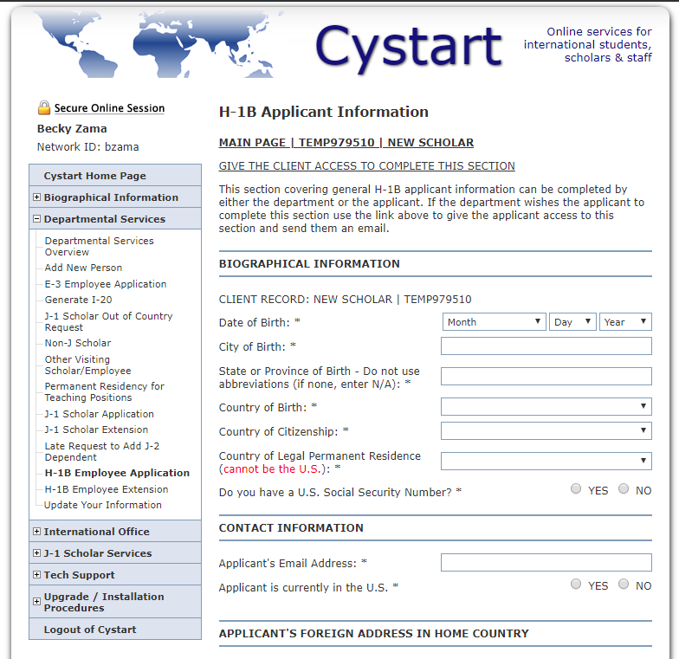

Departmental Services Overview

Choosing Person for Application

After adding a new person to the Cystart database, the system will display your “Administrative and Departmental Services Overview” menu (See Figure 3) that lists the names of all the individuals for whom you have previously submitted cases to the ISSO. You can access your Departmental Services Overview every time you log-in to Cystart. The “Current Cases” menu contains applications submitted in the last 90 days. Click on the “Past Cases” bar to display older applications. The “Case Information Display” shows the person you have just added.
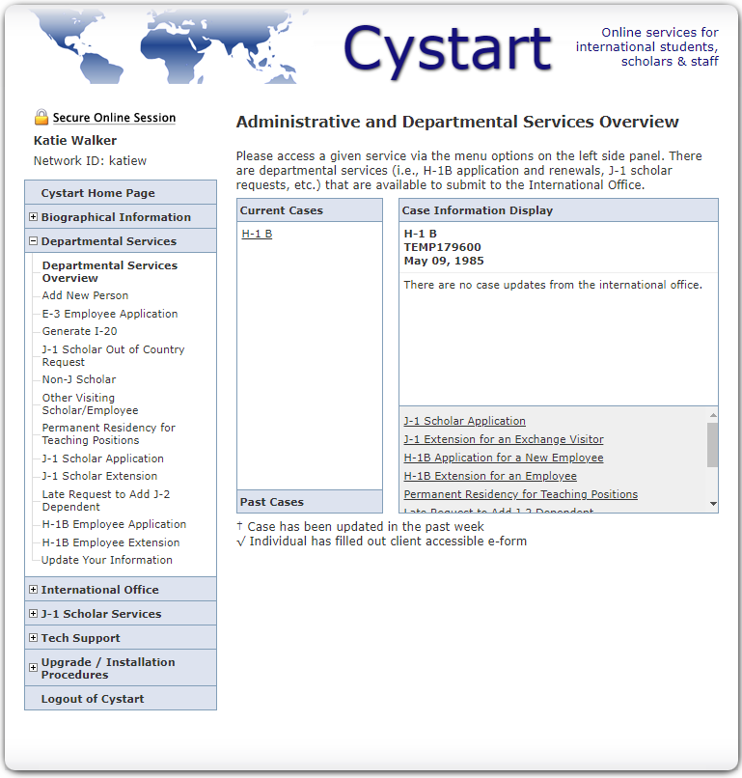
Figure 3: Departmental Services Overview

Choosing the Application Type
To begin an H-1B application, select the name of the individual from the Current Cases list and then select “H-1B Application for New Employee” (See Figure 4). You may choose from the list in the gray shaded area of the Case Information Display or from the left hand drop-down menu under Departmental Services.

Figure 4: Choose application you wish to begin
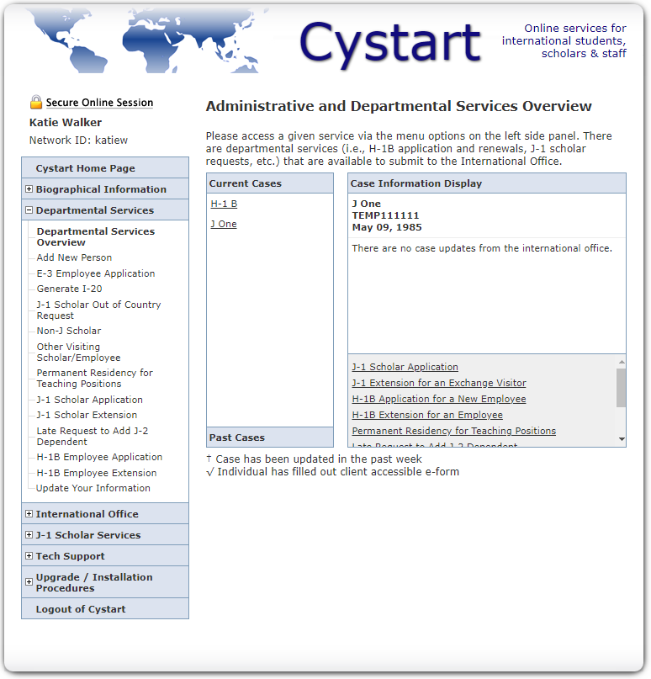

H-1B Application for a New Employee
At this point you will be on the main page for the H-1B application, like the one in Figure 5. The eight links on the middle of the page (“Applicant Information”, etc.) will walk you through the application process. Proceed through each section, providing the information as prompted. The Departmental H-1B Compliance Certification will become available upon the completion of the preceding sections and the Export Control Worksheet. The Export Control Worksheet e-form must be completed only by staff from the Office of Research Integrity. Continue to the “Completing the Application” instructions in this manual to receive further directions for each segment of the H-1B application.
Figure 5: H-1B Application Overview
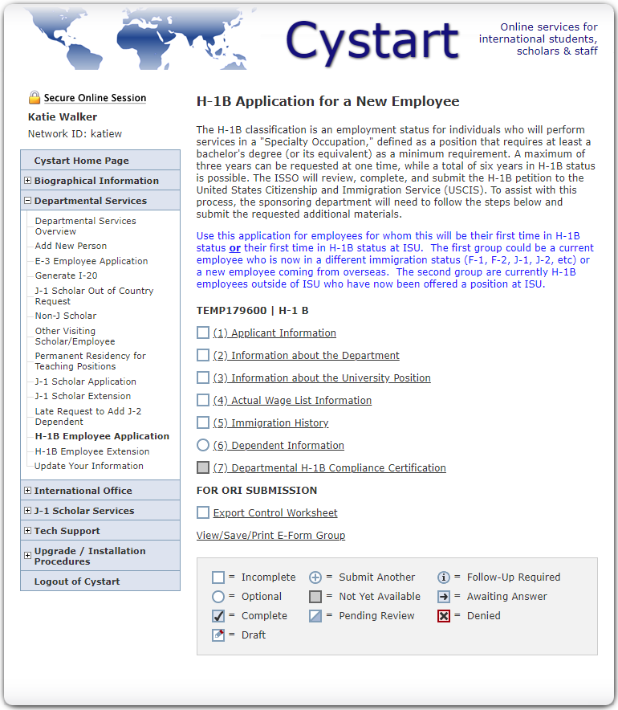

Completing each e-form in H-1B request

E-forms completed by the HRC and/or hiring department (admin+chair)

H-1B Application Fees
- You must provide a Worktag in this form in order to pay the $750 ISSO Scholar Support Fee to ISSO, required for all H-1B applications.
- The hiring department must pay a processing fee and an anti-fraud fee to the Department of Homeland Security. Please process a payment in Workday for a check payable to “Department of Homeland Security” in the amount of $460 (raises to $555 on 10/2/2020) for the processing fee and forward it to the ISSO, 3242 Memorial Union, so that it may be mailed with the H-1B extension application. Do the same for a second check in the amount of $500 for the anti-fraud fee.
  - Include the name of the H-1B beneficiary in the “Supplier’s Invoice Number” line under “Invoice Reference Information” in Workday. This is how we can match incoming checks to applications.
- Indicate if this is a “Premium Processing” application. For an additional fee of $1,440, USCIS will take action (approve, deny, or request additional evidence) on the application in 15 work days. Regular processing times may range from a few weeks to several months, so this service is often necessary if the beneficiary is not currently in H-1B nonimmigrant status. Request a third check for $1,440 through ISU Accounting if premium processing is desired for the application.
  - Include the name of the H-1B beneficiary in the “Supplier’s Invoice Number” line under “Invoice Reference Information” in Workday. This is how we can match incoming checks to applications.

Information about the University Position
- Basis for H-1B Classification (see Figure 8): If this is a first H-1B petition ISU is filing for the beneficiary, they will most likely be entering as a new employee. Additional terms are described below.

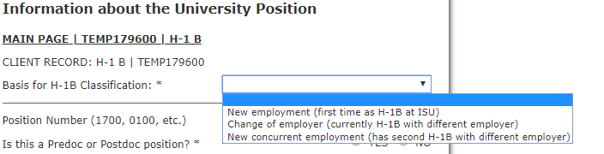
Figure 8: H-1B Classification

  - Select “new employment” if the individual is living outside the U.S. or is inside the U.S. but in a different non-immigrant status (such as F1, J1, TN, etc).

  - Select “change of employer” if the individual is already working on an H-1B petition filed by another employer and will not work for that employer once they begin working at ISU.

  - Select “new concurrent employment” if the individual is already working on an H-1B petition filed by another employer and will continue working for that employer once they begin working at ISU.

- The “Requested End Date” should be no more than 3 years from the start date.
- Please note the 300 character limit for job descriptions.
- Provide the actual address where the employee will perform the duties for the position. This is especially important if the employee works off campus as H-1B required wage rates are determined by the geographic area where the work takes place.
- Information regarding your portion of the Export Control Worksheet is located at the bottom of this e-form. Please read this and complete the required worksheet, following directions in the e-form for submitting the form to the Office of Research Ethics (ORE) or Ames Laboratory. ORE or Ames Lab will upload the approved Worksheet into a separate section of the application in Cystart for you, then notify you by e-mail so you can complete the rest of the H-1 application and forward it to ISSO.

Actual Wage List Information
- Enter information for “comparable” employees. “Comparable” employees are those who now hold the same job title and whose work requires similar education and experience as the person to be hired. This information will help determine the actual wage for the position.
- Do not write the names of the employees, as the information will be public.
- If there are no similarly employed workers, please indicate “No Comparable Employees” in the “Job Title” field. The following are valid reasons why comparable employees are paid more than the H-1B beneficiary and this information is entered in the Notes Section for comparable employees, as applicable.
  - The current employee has more relevant work experience than does the applicant
  - The current employee has more responsibility than the applicant will have
  - When hired, the current employee had more experience related to the position than does the beneficiary or had higher level of education than was required for the position
  - The current employee does not work the same number of hours as will the applicant

(7) Departmental H-1B Compliance Certification
- This form will remain inaccessible until forms 1-6 and the Export Control Worksheet have been completed.
- The information provided in this section corresponds to the Department Chair or Head of the Unit that will employ the H-1B. Once you enter and submit their contact information, they will receive an email asking them to review the submitted information and approve it. If they disagree with any of the submitted information, the individual completing the e-form must log back in to Cystart and make corrections.
- This is the final step in completing the application. Once the H-1B Compliance Certification is approved and submitted, ISSO receives an alert and begins preparing the H-1B petition.
- Requires final approval by ISSO
  - Step completed when ISSO sends the H-1B petition to U.S. Citizenship and Immigration Services

E-form completed by the Office of Research Ethics

Export Control Worksheet
- Only staff from the Office of Research Ethics or Ames Laboratory may complete this e-form.
- You will not need to access this form at all. The steps you must complete related to this process can be found in the Information about the University Position e-form.

E-forms completed by employee who is the future beneficiary of the H-1B petition:

Giving the Client Access
- Select e-forms allow the HR Coordinator to send them to the future scholar for completion. The Applicant Information, Immigration History, and Dependent Information e-forms are three examples. When you open this type of e-form, it will display a link (See Figure 6) at the top of the page entitled “Give the client [H-1B beneficiary] access to complete this section.” You will be prompted to enter the client’s email address and click on the “Send e-mail” box (See Figure 7). The H-1B beneficiary will receive an e-mail message with a link to the e-form and instructions to complete the e-form or e-forms, as appropriate. You will be notified when the e-forms have been completed and will be able to review them.
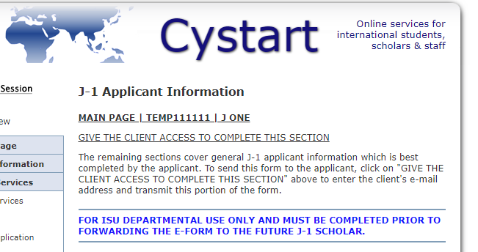
Figure 6: Give Client Access

Figure 7: Give Client Access
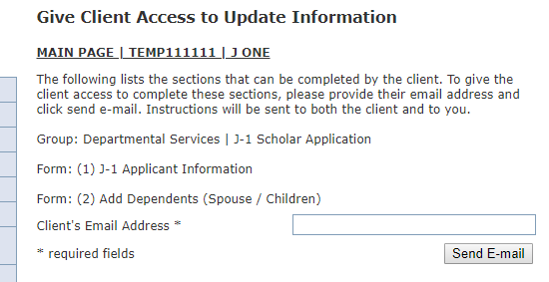

- Click on the “Main Page” link to navigate back to the application.

For informational purposes only as you should direct the employee to complete the following three e-forms.

Applicant (beneficiary) Information
- Select “Give the client access to complete this section” link and enter the client’s email address.
- All sections marked with an asterisk (*) must be completed in order to submit the section.
- The client must provide a copy of the CV (curriculum vitae) and diploma for the highest degree earned, with translations, if applicable, using Cystart’s built-in document upload capabilities.
- When finished with this section (as with each of the others), the client clicks “Submit” at the bottom of the page. This will save the answers and place the section in a queue to be reviewed by ISSO upon the completion of the entire application. After submitting each section, the client will still be able to go back and make changes to information entered. If the client navigates away from the page without clicking “Submit”, all the information which was entered will be lost. If the client wishes to return to complete the section later, the client should select “Save Draft” to be sure all entered content will be saved. We advise against ever clicking the “Cancel” or “Save Defaults” buttons.

(5) Immigration History
- Select “Give the client access to complete this section” link and enter the client’s email address.
- If the H-1B beneficiary has been in the U.S. as a J-1 or J-2, he/she must complete an additional set of questions/instructions.
  - The 212(e) two year home residency requirement, or foreign residence requirement, refers to Section 212(e) of the Immigration and Nationality Act (INA). The J-1 exchange visitor subject to this requirement may not change their status to that of H, L, or K, or to immigrant or legal permanent status until they have fulfilled the two-year foreign residence requirement by going back to their home country (being physically present there for two years) or receiving a waiver of this requirement.
  - A J-1 exchange visitor who is subject to but does not wish to comply with the two-year foreign residence requirement may apply for a waiver of that requirement under any one of the five applicable grounds for a waiver set forth in the INA 212(e). Click here to learn about the grounds for waivers and instructions on how to apply for waiver.
- If the beneficiary has been in the U.S. with either H or L non-immigrant status, the individual will be asked to complete an additional set of questions/instructions detailing that history.
  - Provide dates for each period of stay consecutively, starting with the most recent and working back.
  - A “period of stay” means the uninterrupted period in the U.S.

(6) Dependent Information
- Select “Give the client access to complete this section” link and enter the client’s email address.
- There are additional steps to be taken if the H-1B beneficiary’s family members are included on the application. A link to the required USCIS Form I-539 is embedded in this section. The oldest family member applying for H-4 (dependent) status completes and signs Form I-539. All other family members applying for H-4 status are to be listed on Supplement 1 of Form I-539. The completed form should be returned to 3242 Memorial Union, along with a personal check or money order of $370 payable to “Department of Homeland Security,” plus Form I-539A and an $85 biometric fee for each family member apply for H-4 status.
- The H-1B beneficiary must upload several documents for the dependents. These should be compiled into one document for each family member as a single PDF or JPEG file; for example, a single PDF or JPEG containing the passport demographic pages of each family member.
Appendix A

Information required for each e-form in request

E-forms completed by the HRC and/or hiring department (admin+chair)

(2) H-1B Application Fees
- Worktag for assessment of this fee
  - Requires final approval by ISSO and may not approve this for a few weeks; this will not delay filing of the H-1B petition

(3) Information about the University Position
- Basis for H-1B classification
- Job Profile tile from Workday and if Predoc or Postdoc, type of appointment
- Annual Work Period (9 or 12 months), offered salary, and FTE percentage from Workday
- Requested start and end dates for H-1B employment
  - Please consult with ISSO to select the start date
  - End date may be up to three years from start date, but is dependent on documentation of available funding for entire period requested (i.e., a one-year term appointment would limit the end date to one year from the start start)
- Broad academic field, specific subfield and brief summary of proposed duties from Workday
- Name of hiring unit, Immediate supervisor name, title, and e-mail address from Workday
- Address (street and office) of all office locations where duties will be performed, percent of time at off-campus location
- Number of non-student, full-time employees the H-1B beneficiary will supervise from Workday
- Minimum degree, including academic field, required from Workday
- Additional on-the-job training required to perform this job outside of the experience gained during degree program, if applicable, from Workday
  - If required, list minimum number of years, months, and type of training required
- Other requirements for the position (i.e., required license/certification, knowledge of a type of equipment), if applicable, from Workday
  - If yes, please explain

(4) Actual Wage List Information
  - For H-1B beneficary: years of directly related experience (include all employers) at time of hire
  - For similarly employed faculty/staff: department, job title, brief job description (2-3 sentences), academic field of ISU position, number of non-student full-time employees the employee supervises, salary, years of directly related experience (include all employers) by the time the H-1B beneficiary is offered a position

(7) Departmental H-1B Compliance Certification
- Name of hiring Department/Unit/Division
- Name of Department Chair/Unit or Division Director
- Title
- Email

E-form in the group that are completed by the Office of Research Ethics:

Export Control Worksheet

E-forms completed by employee who is the future beneficiary of the H-1B petition:

(1) Applicant Information
- Personal information such as date of birth, city, state, and country of birth, country of citizenship, and country of legal permanent residence
- Contact information including e-mail and home address
- Academic information for highest degree earned (level, academic field, date earned)
  - If the degree required for the position was earned at a foreign institution, the applicant must request a credential evaluation from a service which performs these
- Payroll records if currently working in the U.S. for a U.S. employer
- DS-2019 form(s), if beneficiary or any of their dependents have ever been in the U.S. as a J-1 or J-2
- It the applicant has been in the U.S. in either H or L classification in the last six years, attach copies of Forms I-94 (original or print out of electronic I-94), I-797 and/or other USCIS issued documents noting these periods of stay in the H or L classification

(5) Immigration History
  - Passport information
  - Information regarding current or previous immigration status for stays in the U.S.
  - Dates of stay for any time in the U.S. in J-1, J-2, H-1B, H-4, L-1, L-2 nonimmigrant status
  - 212(e) information
  - Information about any any I-140 or I-130 or I-485 that is pending or has been approved
  - Foreign mailing address
  - U.S. consulate (city, country) that H-1B beneficiary would go through if consular processing is required
    - For Canadians (no visa is required), whether to file for preclearance at an airport in Canada or for port-of-entry

(5) Dependent Information
  - Spouse and any children under the age of 21
  - Number of family members included in the I-539

Appendix B

Documents for each e-form in request

Supporting documents uploaded to Cystart request by HRC and/or department admin:

- Appointment Letter/Letter of Intent)

- Offer Letter

- Position Description Responsibilities, Position Responsibility Statement, or other document that details the duties of the position.

Supporting documents required to complete the Cystart request, but not uploaded to Cystart by HRC and/or department admin:

- Passport Demographic Page

- Export Control Worksheet

Supporting documents uploaded to Cystart by Office of Research Ethics:

- Export Control Worksheet

Supporting documentation to be uploaded to Cystart request by H-1B beneficiary:

Information on beneficiary’s experience and academic background:
- Current CV (Curriculum Vitae) or Resume
- Diploma for the highest degree earned (also an English translation, if necessary)
- Credential evaluation of diploma (by a credential evaluation service)
- Academic transcript for highest degree earned (also an English translation, if necessary)

Information on beneficiary’s U.S. immigration history:
- Passport Demographic Page
- U.S. visa pages (all passport pages if have been in the U.S. in J-1, J-2, H-1B, H-4, L-1 or L-2 nonimmigrant status)
- All DS-2019 form(s) for the beneficiary and/or any of their dependents if have been in the U.S. as a J-1 or J-2 in the past
- Department of State Recommendation Letter and, if received, I-797 Approval Notice from U.S. Citizenship and Immigration Services for waiver of 212(e) requirement, if applicable
- All I-797 Approval Notice(s) for the beneficiary and/or any of their dependents if have been in the U.S. in H-1B, H-4, L-1 or L-2 nonimmigrant status in the last six years
- All I-797 Receipt Notices or Approval Notices for an I-130, I-140, or I-485 for or attached to the beneficiary and/or for any of their dependents

Additional information on beneficiary’s U.S. immigration history if currently in the U.S.:
  - I-94 card (original or print out of electronic I-94)
  - Most recent U.S. visa stamp
  - Current Form I-20 (if applicable)
  - Current Form DS-2019 (if applicable)
  - Any USCIS I-797 Approval Notices or Receipts
  - Employment Authorization Document (if applicable)

Information if the H-1B beneficiary’s family is in the U.S. and applying for a change of status:
  - Passport demographic pages
  - I-94 card(s) (original or print out of electronic I-94)
  - Most recent U.S. visa stamp(s)
  - Current Form I-20(s) (if applicable)
  - Current Form DS-2019(s) (if applicable)
  - Any USCIS I-797 Approval Notices or Receipts
  - Employment Authorization Document(s) (if applicable)
  - Marriage certificate (spouse), original and English translation (if necessary)
  - Birth certificate (children born outside the U.S.), original and English translation (if necessary)
  - Form I-539

Appendix C

Formatting Names in Cystart

(Excerpts from Name Standards from the U.S. Department of Homeland Security website)

SEVIS Name Standards Tied to Standards for Machine-readable Passport
Standards for machine-readable passports were put together by an international organization. . .Here are the SEVIS name standards:
- Upper or lower case Roman alphabet only
- No special characters
- No hyphens, apostrophes, or commas
- One space between names
SEVIS names will be consistent with the standards in a passport’s MRZ [machine readable zone], with a few exceptions.
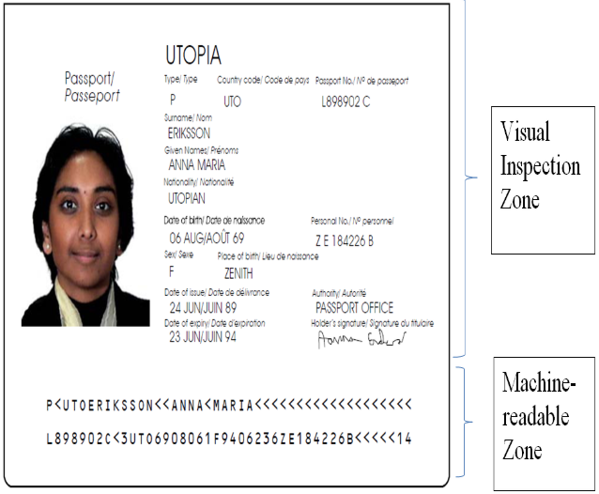
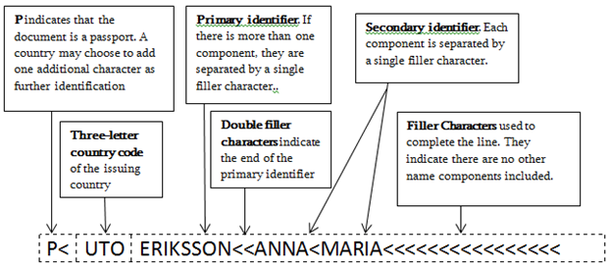
U.S. Department of Homeland Security Study in the States website: https://studyinthestates.dhs.gov/sevis-help-hub/sevis-basics/system-data-entry-standards/name-standards

Appendix D

Glossary of Terms
Dependent: A spouse or unmarried child (under the age of 21). Dependents are eligible to apply for visas so that they may reside in the United States with the scholar or H-1B employee.
Deportation: The formal removal of an alien from the United States when the alien has been found removable for violating the immigration laws.
DS-2019: The Form DS-2019 or “Certificate of Eligibility for Exchange Visitor (J-1) Status” is the basic document used in the administration of the exchange visitor program. This form permits a prospective exchange visitor to seek an interview at a U.S. embassy or consulate in order to obtain a J visa to enter the United States. The Form DS-2019 identifies the exchange visitor and their designated sponsor and provides a brief description of the exchange visitor’s program, including the start and end date, category of exchange, and an estimate of the cost of the exchange program. Read the detailed description of the Form DS-2019.
EAD: An Employment Authorization Document is a driver’s-license-like card issued by USCIS for off-campus employment authorization. The most common EAD is issued to F-1 students who have completed their program of study and have been approved for optional practical training or “OPT.”
Exclusion: The formal term for denial of an alien’s entry into the United States.
H-1B: The H-1B classification is an employment status for individuals who will perform services in a specialty occupation for a U.S. employer. Specialty occupations are those that require at least a bachelor's degree in a particular specialty to perform. Individuals cannot self-petition; Iowa State University must file the H-1B petition. See the ISSO website or the Bureau of Consular Affairs for more information.
H-4: The dependents (spouses and unmarried children under 21) of H-1B employees.
Cystart: The online database on which the International Students and Scholars Office maintains records of all past and present international applicants, students, scholars, and employees.
J-1: The Exchange Visitor (J) non-immigrant category is for individuals approved to participate in work and study based exchange visitor programs, which enable foreign nationals to visit the United States in order to experience life in the US. Before individuals can apply at a US embassy or consulate for a J visa, they must first apply, meet the requirements, and be accepted to an exchange visitor program through a designated sponsor organization. The Bureau of Consular Affairs has additional information about the Exchange Visitor (J) visa. The International Students and Scholars Office manages Iowa State University’s J-1 exchange visitor program.
J-2: The J-2 is a nonimmigrant status which allows the dependents (spouses and unmarried children under 21) of J-1 student visa holders to enter into the US.
Non-immigrant status: Non-immigrant status is granted by USCIS when a foreign national arrives in the United States. The status matches the classification of visa the bearer has been granted by the US Department of State, categorized according to the principal purpose for the visit. With few exceptions, while in the US, non-immigrants are restricted to the activity for which their visa was issued. Examples of non-immigrant statuses include J-1 (exchange student or scholar), F-1 (student), H-1B (temporary worker), etc. For more information, see Temporary Visitors to the U.S.
SEVIS: SEVIS (Student and Exchange Visitor Information System) is an Internet-based system that provides tracking and monitoring functionality, with access to accurate and current information on nonimmigrant students (F and M visa) and exchange visitors (J visa), and their dependents (F-2, M-2, and J-2). SEVIS enables schools and program sponsors to transmit required information and event notifications, via the Internet, to the U.S. Department of Homeland Security and Department of State throughout a student's or exchange visitor's stay in the United States. Read a detailed description of SEVIS.

Information gathered from the ISSO website, http://www.isso.iastate.edu/, and the U.S. Department of State, http://www.state.gov/

